IN-CAA Respiratory Protection Plan

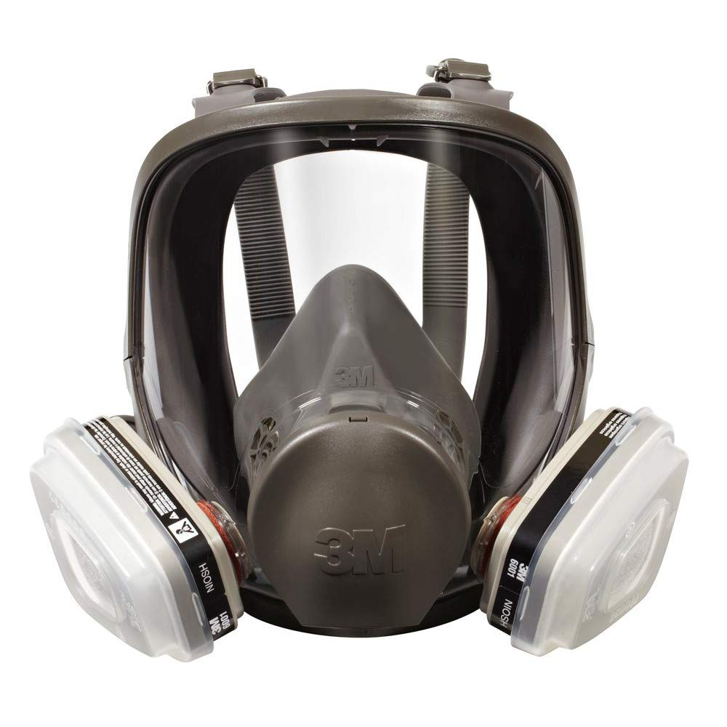

March 2020

Introduction
Respirators are used to protect employees from inhaling hazardous substances in the air. These substances can be in the form of gases, vapors, mists or dust. We provide respirators to our employees to protect them from airborne hazards. The following is the written respiratory protection program. In this document, we spell out how you do the following in our workplace:
- How the proper respirators for the particular hazards are selected and issued,
- When and how respirators will be used in routine work activities, infrequent activities, and foreseeable emergencies such as spill response, rescue or escape situations,
- How medical evaluations of respirator user is provided,
- How respirator fit-testing is done,
- How and when respirators in use are cleaned, stored, inspected and repaired or discarded
- How employees are trained about respiratory hazards at your workplace,
- How employees are trained on the proper use of the respirators used at your workplace,
- How you evaluate the effectiveness of your respiratory program.

The answers to the above questions will depend on the unique conditions at your workplace. The information must be specific and reflect what you actually do or what is to be done, not just what seems like the right thing to do. It must describe actual conditions and actions at your workplace.
To provide proper protection, respirators must be the right type, must be worn correctly at all times, and must be maintained properly. They are prone to leakage, depend on the behavior of individual employee and will require maintenance and management oversight. This is why they are considered, as a last resort, to protect employees from airborne hazards.
It is often more protective, less trouble, and less costly to eliminate or reduce the respiratory hazard through various ways such as exhaust ventilation, changes in process, or enclosure of the process. Sometimes the use of a hazardous material itself can be eliminated. When there is no alternative, this respiratory program will be implemented to protect INCAA employees from adverse health effects of exposure to hazardous materials in the air above their permissible exposure limits.
Respirators are typically used in three different situations – routine or regular exposure to processes or activities involving harmful substances, infrequent, but predictable occasions where there is exposure; or emergencies where there is a leak or spill. This written respiratory program addresses these situations if they occur or could occur at INCAA.
The WISHA Respirators Rule requires that you designate one person as the “program administrator” who is responsible for the whole program. This person should be reasonably knowledgeable about exposure; respirators and their uses; respirator limitations; and that person will need to keep track of respirator fit-testing, use, storage, cleaning and maintenance. This job will not be given to an untrained or unmotivated employee. Training for persons acting as respirator program administrators is available online from various training vendors, and from some respirator vendors.

Respiratory Protection Program for
Indiana Community Action Association
Our respirator program administrator is Michael Hastings
Our administrator’s duties are to oversee the development of the respiratory program and make sure it is carried out at the workplace. The administrator will also evaluate the program regularly to make sure procedures are followed, respirator use is monitored, and respirators continue to provide adequate protection when job conditions change.

Selection of Respirators
We have evaluated our potential exposure in this work place and found that employees must use respirators when potential exposure may occur to the following substances. These substances may be encountered during daily work activities while installing or supervising work in various work areas including attics, crawl spaces, etc.
Employee position or activity | Chemicals or products used | NIOSH approved respirators assigned | When used (routinely, infrequently, or in emergencies)
For All IN-CAA training and all IN-CAA production staff | Cellulose | Filtering Face Piece N95 or greater | Routinely
 | Fiberglass | Filtering Face Piece  N95 or greater | Routinely
 | Lead | Filtering Face Piece or Half Mask minimum P100 | Routinely
 | Potential Asbestos | Filtering Face Piece or Half Mask minimum P100 | Routinely
 | Low pressure Plural component spray foam | Full face 3M with Yellow/Magenta cartridge | Infrequently
 | Mold spores | Filtering Face Piece or Half Mask P100 | Routinely
 | Other biologicals, Fecal contaminants, VOC’s, nuisance dust particulates | Filtering Face Piece  N95 or greater | Routinely
 | Air borne biologicals bacteria, viruses, etc | Filtering Face Piece  N95 or greater | Infrequently
We selected these respirators based on the following information:
Material manufactures recommendations, Respirator manufacturer recommendations, OSHA Requirements and installer personal preference (within reason).

Medical Evaluations

Nova Medical center 500 north capitol st Indianapolis IN 46204
317.983.5400
Walk in only no appointment
Pulmonary testing
Osha questionnaire
Corporate account manager
Every employee of this company who must wear a respirator will be provided with a medical evaluation before they are allowed to use the respirator. Our first step is to give the attached medical questionnaire to those employees. Employees will be seen by a medical professional for necessary pulmonary testing and the medical clearance questionnaire. INCAA has obtained the service of NOVA medical center to provide this service. Questionnaires are confidential and will be sent directly to medical provider without review by management.
If the medical questionnaire indicates to our medical provider that a further medical exam is required, this will be provided at no cost to our employees by NOVA Medical Center. We will receive a recommendation from this medical provider on whether or not the employee is medically able to wear a respirator.
Additional medical evaluations will be done in the following situations:
our medical provider recommends it,
our respirator program administrator decides it is needed,
an employee shows signs of breathing difficulty,
changes in work conditions that increase employee physical stress (such as high temperatures or greater physical exertion).
Note NOVA medical utilizes their own medical questionnaire.

Respirator Fit-testing

All employees who wear tight-fitting respirators will be fit-tested before using their respirator or provided a new one. Fit-testing will be repeated annually. Fit-testing will also be done when a different respirator face piece is chosen, when there is a physical change in an employee’s face that would affect fit, or when our employees or medical provider notify us that the fit is unacceptable. No beards are allowed on wearers of tight-fitting respirators. Respirators are chosen for fit-testing following procedures in the WISHA Respirators Rule (Table 11) Fit-testing is not required for loose-fitting, positive pressure (supplied air helmet or hood style) respirators. We do fit-testing using

Banana Oil (isoamyl acetate) protocol
Saccharin protocol

The quantitative fit-testing instrument we use is: 3M hood and Saccharin Solution
Documentation of our fit-testing results is kept in our Injury and illness protection prevention program binder.
Our respirators will be checked for proper sealing by the user whenever the respirator is first put on, using the attached seal check procedures:
Once the respirator is donned the user will place his/her hands over the inlet orifice or cap the end of the canister filters with their hands and insure that the respirator will suck in on their face while inhaling. This test is to verify the actual fit on the face and the integrity of diaphragms within the mask.

Respirator storage, cleaning, maintenance and repair

Our non-disposable respirators will be stored in the following clean locations:
IN-CAA training staff may store respirators in a clean zip lock like bag in their individual offices, vehicles, or labs as necessary for easy access.
IN-CAA production staff may store respirators in a clean zip lock like bag in their individual offices, vehicles, or labs as necessary for easy access.
Respirators will be cleaned and sanitized before being placed in their storage bags, or whenever they are visibly dirty. (this does not apply to paper dust masks which are disposed daily). Respirators will be cleaned according to the attached instructions (either the manufacturer’s instructions or the Respirators Rule cleaning procedures.)
If filter has been exposed to contaminants they must be capped and stored in a separate bag. This can preserve their useful life and prevent contaminating the stored respirator.
All respirators will be inspected before and after every use and during cleaning.
Respirators shall be inspected for damage, deterioration or improper function and be repaired or replaced as needed. Respirator repair and adjustment will be supervised by Michael Hastings. He is designated as the competent person for respirator maintenance and repair.
When supplied air respirators are used, any needed repairs or adjustments will be completed or supervised by the competent person. On respirators with vapor or gas cartridges, the cartridges will be regularly replaced on the following schedule:
Refer to respirator manufacturer for recommended replacement schedule for each brand and type of respirator. Or consult with program administrator for further guidance and assistance.
N95 and P100 particulate filters will be changed when they become visibly soiled or there is difficulty breathing through the filter.
Organic vapor cartridges used in the application of low pressure spray foam will be changed at an interval or 40 hours or use or every 30 days whichever comes first, when any smell or taste of chemical is noticed, when the pre filter becomes soiled, or when there is difficulty breathing through the filter. (Per manufacturer recommendations)
Please see attached 3M filter cartridge report for actual hours of cartridge life.

Respirator Use

The program administrator will monitor (or defer monitoring to individual crew leaders) the work area in order to be aware of changing conditions where employees are using respirators.
Employees will not be allowed to wear respirators with tight-fitting face pieces if they have facial hair (e.g., stubble, bangs) absence of normally worn dentures, facial deformities (e.g., scars, deep skin creases, prominent cheekbones), or other facial features that interfere with the face piece seal or valve function. Jewelry or headgear that projects under the face piece seal is not permitted.

If corrective glasses or other personal protective equipment must be worn, it will not interfere with the seal of the face piece to the face.
Reasonable accommodations will be made for employees that do not meet the conditions listed above with loose fitting hood style respirators.
Note: Full-face piece respirators can be provided with corrective glasses since corrective lenses can be mounted inside a full-face piece respirator. Contact lenses can also be used with full facepiece respirators if they do not cause any problems for the employee.
A seal check will be performed every time a tight-fitting respirator is put on.
The program administrator will make sure that the NIOSH labels and color-coding on respirator filters and cartridges remain readable and intact during use.
Employees will leave the area where respirators are required for any of the following reasons:
to replace filters or cartridges,
when they smell or taste a chemical inside the respirator,
when they notice a change in breathing resistance
to adjust their respirator,
to wash their faces or respirator,
if they become ill,
if they experience dizziness, nausea, weakness, breathing difficulty, coughing, sneezing vomiting, fever or chills,
If a atmosphere monitoring alarm signals the user.

The program administrator has identified the following areas or job duties as presenting the potential for IDLH (immediately dangerous to life or health) conditions: To the best of our knowledge the employees of IN-CAA are not exposed to IDLH atmospheres.

Respirator Training

Training is conducted by a qualified person before employees wear their respirators and annually thereafter as long as they wear respirators. Respirator annual check ideally will occur at the time of the employee’s annual review. Our supervisors or crew leaders who wear respirators or supervise employees who wear respirators, will also be trained on the same schedule.
Additional training will also be done when an employee uses a different type of respirator or workplace conditions affecting respiratory hazards or respirator use have changed.
Training will cover the following topics:
Why the respirator is necessary,
The respirator’s capabilities and limitations,
How improper fit, use or maintenance can make the respirator ineffective,
How to properly inspect, put on, seal check, use, and remove the respirator,
How to clean, repair and store the respirator or get it done by someone else,
How to use a respirator in an emergency or when it fails,
Medical symptoms that may limit or prevent respirator use,
Our obligations under the Respirators Rule.

Respiratory Program Evaluation

We evaluate our respiratory program for effectiveness by doing the following steps:
- Checking results of fit-test results and health provider evaluations.
- Talking with employees who wear respirators about their respirators – how they fit, do they feel they are adequately protecting them, do they notice any difficulties in breathing while wearing them, do they notice any odors while wearing them, etc.
- Periodically checking maintenance and storage of respirators.
- Periodically checking how employees use their respirators.

Recordkeeping

The following records will be kept:
A copy of this completed respirator program
Employees’ most recent fit-testing results
Employee training records
Written recommendations from our medical provider
These records will be kept at the following location: This information is kept in IN-CAA’s Injury and Illness prevention program binder housed in the office of our administrative assistant. Along with availability for electronic distribution to interested parties.

Employees will have access to these records upon request but will only be allowed access to their own records and not that of any other employee.

Respirator Fit Test Record

Name: __________________________________________________ Initials: ________

Type of qualitative/quantitative fit test used: _________________________________

Name of test operator: _____________________________________ Initials: _______

Date: _________________

Respirator Mfr./Model/Aproval no. Size Pass/Fail or Fit Factor

Note: “Fit factor” is numerical result of quantitative fit test from instrument reading

1. _______________________________________S M L P F _____

2. _______________________________________S M L P F _____

3. _______________________________________S M L P F _____

4. _______________________________________S M L P F _____
Clean Shaven? Yes___ No___ (Fit-test cannot be done unless clean-shaven)
Medical Evaluation Completed? Yes___ No___
NOTES: _____________________________________________________________
____________________________________________________________________
____________________________________________________________________
____________________________________________________________________

This record indicates that you have passed or failed a qualitative or quantitative fit test as shown above for the particular respirator(s) shown. Other types will not be used until fit tested.

Respirator Training Record
___________________________________________
Employee Name (printed)
I certify that I have been trained in the use of the following respirator(s):

This training included the inspection procedures, fitting, maintenance and limitations of the above respirator(s). I understand how the respirator operates and provides protection. I further certify that I have heard the explanation of the respirator(s) as described above and I understand the instructions relevant to use, cleaning, disinfecting and the limitations of the respirator(s).

__________________________________
Employee Signature

__________________________________
Instructor Signature

__________________________________
Date

Employer-Provided Information for Medical Evaluations

This form may be used by the employer to give to your medical provider, information on respirator use by your employees, but it is not a required form. You can also consult directly with your medical provider and discuss the information below.
You must also give the medical provider a copy of your written respiratory program and copy of the Respirators Rule

Specific Respirator Use Information

Employee Name: ___________________________________________

Company name: _________________________________________________

Employee job title: __________________________________________

Company Address: _______________________________________________

Company contact person and phone #:_______________________________________________________
1. Will the employee be wearing protective clothing and/or equipment (other than the respirator) when using the respirator?
Yes/No _______ If “Yes,” describe protective clothing and/or equipment:
______________________________________________________________________________________________________________________________
______________________________________________________________________________________________________________________________
2. Will employee be working under hot conditions (temperature exceeding 77°F)?
Yes/No ________ If “Yes”, describe nature of work and duration:
______________________________________________________________________________________________________________________________
______________________________________________________________________________________________________________________________
3. Will employee be working under humid conditions? Yes / No_______
4. Describe any special or hazardous conditions the employee could encounter when using the respirator (for example, confined spaces, life-threatening gases).
________________________________________________________________________________________________________________________________________________________________________________________________________________________

Specific Respirator Use Information, Continued
Check Box | Respirator Type | Face / Head Cover Type  (half or full face, helmet, or hood) | Frequency of Use  (hours per day, week, or month) | Work Effort  Light, Moderate, Heavy  (see descriptions below) | Respirator Wt.
 | Disposable facepiece particulate filter  (N, R or P series) | 1/2 facepiece
 | Mask with replaceable filter or cartridge
 | Mask with canister
 | Powered air-purifying respirator (PAPR)
 | Air line, continuous flow
 | Air line, negative pressure demand
 | Air line, positive pressure demand
 | SCBA, negative pressure demand | Full facepiece
 | SCBA, positive pressure demand | Full facepiece

Work Effort Descriptions
Examples of a light work effort are sitting while writing, typing, drafting, or performing light assembly work; or standing while operating a drill press (1-3 lbs.) or controlling machines.
Examples of moderate work effort are sitting while nailing or filing; driving a truck or bus in urban traffic; standing while drilling, nailing, performing assembly work, or transferring a moderate load (about 35 lbs.) at trunk level; walking on a level surface about 2 mph or down a 5-degree grade about 3 mph; or pushing a wheelbarrow with a heavy load (about 100 lbs.) on a level surface.

Examples of heavy work effort are lifting a heavy load (about 50 lbs.) from the floor to your waist or shoulder; working on a loading dock; shoveling; standing; standing while bricklaying or chipping castings; walking up an 8-degree grade about 2 mph; climbing stairs with a heavy load (about 50 lb.).
Seal Check Procedures (from Respirators Rule)

Respirator Cleaning Procedures (from Respirators Rule)

